Contents

1.Select an appropriate visual: 3

1.1 Categorical visuals : 4

1.2 Time series visuals 5

1.3 Proportional visuals 7

1.4 Numeric visuals 9

1.5 Grid visuals 10

1.6 Performance visuals: 11

1.7 Geospatial visuals : 12

1.8 Visual layout : 12

2.Format and configure visuals : 13

2.1 You can drag and drop the visual and size it directly on power bi 14

2.2 Map semantic model to field allow to drag and drop model semantic in order to see your visualization in function of your visualization you can have more semantic model available . 15

2.3 You can apply visual filter in the visual or directly in the page or in the report . 16

2.4 Modify field mappings, possibly renaming fields, modifying summarization behavior 16

2.5 Optionally, modify the sort field and the sort of direction (in ascending or descending order). 17

2.6 Apply format options to produce the desired result and style. 18

2.7 use the **Analytics** options to overlay supporting data, like minimum or maximum lines, or Artificial Intelligence (AI) results, like anomaly detection and forecasts. 18

3.Apply and customize a theme: 19

3.1 Select from the available built-in report themes 20

3.2 Customize current theme 21

3.3 Json theme 21

4)Apply conditional formatting : 22

5) Apply slicing and filtering 22

5.3 Apply filter to report structure : 23

5.2 Apply slicer 24

6)Configure the report page (Improve if time): 26

7. When to use paginated report 27

8.Create visual with Dax 27

9.Configure Bookmark 29

10.Create custom tooltip 29

10.1 Default tooltip. 30

10.2 Custom tooltip 30

11. Edit and configure interaction between visuals. 32

12. Configure Navigation for a report. 33

13. Apply sorting to visuals 33

14. Group and layer visuals by using Selection pane . 34

15. Configure drill through navigation 34

16 configure export settings 34

17. Design report for mobile device . 34

18. Enable personal visuals in report 34

19. Design power bi for accessibility 34

20 .Configure automatic page refresh 35

21) Use the Analyze feature in Power bi 35

22) Use grouping,binning and clustering 37

23) Use AI visuals 37

Key influencers 37

Decomposition tree 37

QA: 38

24) Use reference line,error bars and forecasting 38

25) Detect outliers and anomalies 38

# 1.Select an appropriate visual:

In power bi you have access to the visual thank to the visual pane and elements:

The purpose of visualization is to communicate information but in a way that is the most relevant for the reader.

Selecting the wrong visual type could make it difficult for report consumers to understand the data, or worse, it could result in the misrepresentation of the data.

We will divide visual into 7 categories:

1. Categorical visuals
2. Time series visuals
3. Proportional visuals
4. Numeric visuals
5. Grid visuals
6. Performance visuals
7. Geospatial visuals
8. Visual layout

## 1.1 Categorical visuals :

 Bar or column charts are good choices when you need to show data across multiple categories.

## 1.2 Time series visuals

Always use a line or column chart to show values over time. The X-axis should present time, sorted from earliest to latest periods (left to right).

Line chart is the perfect visual for time series but if flow of data is consistent (no gap in the data)

Stacked column chart :

Area chart :

Line and stacked column chart :

Ribbon chart :

## 1.3 Proportional visuals

Proportional visuals show data as part of a whole. They effectively communicate how a value is distributed across a dimension. Column and bar chart visuals work well for visualizing proportions across multiple dimensions.

You have 100% stacked bar chart and Column chart .

## 1.4 Numeric visuals

## 1.5 Grid visuals

You have 2 grid visuals matrix and table , you can use conditional formatting and add in it some graphs, colors and other things.

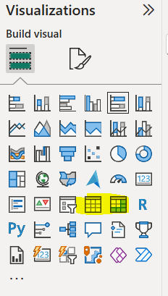

## 1.6 Performance visuals:

The Performance visual compare data to target , and with power bi you have just 4 visuals :

KPI,Gauge, table with conditional and matrix with conditional formmating

## 1.7 Geospatial visuals :

When a semantic model stores geospatial information, it can be conveyed by using map visuals. Power BI includes several core map visuals. Each visual offers various formatting options that, when appropriately applied, can help highlight geospatial data.

## 1.8 Visual layout :

Often, you can choose between multiple visual types to meet design requirements. To narrow down the selection, you might also consider the visual that best fits the available space on the report page. Use a visual that is aesthetically pleasing while maximizing the use of the available page space.

The following examples show two visuals side by side: a 100% Stacked Bar chart visual and a 100% Stacked Column chart visual. Each visual shows the same data and occupies the same space on the page. One visual is easier to read. In this instance, the 100% Stacked Bar chart visual helps make it easier for you to determine relative values. The reason is because the visuals occupy a wide yet short area: The lengths of the long bars are easier to interpret than the heights of the short columns.

It will depend in function of the length of the column or bar .

# 2.Format and configure visuals :

## You can drag and drop the visual and size it directly on power bi

## 2.2 Map semantic model to field allow to drag and drop model semantic in order to see your visualization in function of your visualization you can have more semantic model available .

## 2.3 You can apply visual filter in the visual or directly in the page or in the report .

## 2.4 Modify field mappings, possibly renaming fields, modifying summarization behavior

You can modify fields mappings changing the field in the X-axis and Y-axis or legend .

You can rename fields directly in the visualization pane

You have the possibility to modify the summarization with Average,Median etc. ..

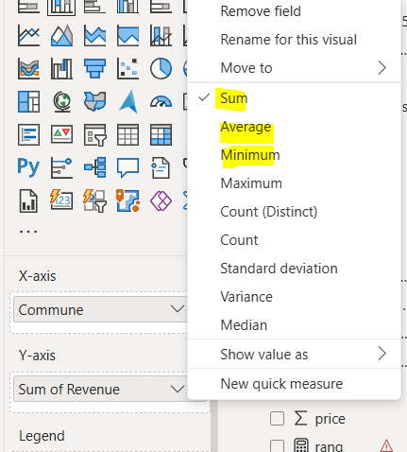

## 2.5 Optionally, modify the sort field and the sort of direction (in ascending or descending order).

## 2.6 Apply format options to produce the desired result and style.

## 2.7 use the **Analytics** options to overlay supporting data, like minimum or maximum lines, or Artificial Intelligence (AI) results, like anomaly detection and forecasts.

# 3.Apply and customize a theme:

In power bi, you have 3 ways to apply a theme, you can just take in the power BI desktop directly in view. download a theme in gallery, customize a theme.

## 3.1 Select from the available built-in report themes

You can download a theme-on-theme gallery or customize a current theme

## 3.2 Customize current theme

You can do that with name, colour, text , visuals , page and filter pane .

## 3.3 Json theme

Documentation for more example :

<https://learn.microsoft.com/en-us/power-bi/create-reports/desktop-report-themes#example-report-theme-json-file>

# 4)Apply conditional formatting :

Conditional formatting is used for Table and Matrix, it allows to create colour , add graph and image on your table to highlight data.

# 5) Apply slicing and filtering

There are several ways to filter your data with Power bi .

You can filter the semantic model directly with Row level security (RLS).

You can also filter directly on the report at various level with the filter pane: Report level,Page level or visual level and you can also filter directly in the measure with DAX.

## 5.3 Apply filter to report structure :

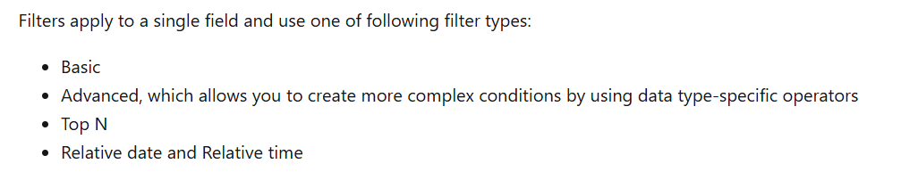

You can lock filters to ensure that report consumers can't remove or modify them. It's a good idea to lock filters that are critical to the design of the report, page, or visual. Additionally, you can hide filters. A hidden filter isn't visible to report consumers. Consider hiding a filter when the report consumer doesn't need to know about it, such as when filters are cleaning up the data, perhaps by removing BLANKs.

## 5.2 Apply slicer

The Slicer is a core visual with one purpose: *filter other visuals*. It's one of the most common visuals that you add to a report page because it presents an intuitive way for report consumers to filter data. As a report author, you have considerable control over how the visual is laid out and formatted and how it functions.

You have various slicers in function of the semantic model use .

# 6)Configure the report page (Improve if time):

You can configure in the visualization pan, the size and alignment of the canvas, you can also customize it but be aware that it will impact the time of rendering! and more visualization impact also the rendering.

# 7. When to use paginated report

*Paginated reports* are designed to be printed or shared. They're called *paginated* because they're formatted to fit well on a page. They display all the data in a table, even if the table spans multiple pages. You can control their report page layout exactly. Power BI Report Builder is the standalone tool for authoring paginated reports for the Power BI service.

You should use **Paginated Reports** in Power BI when you need highly formatted, printable, or pixel-perfect reports that are optimized for printing or PDF generation. These are best suited for scenarios where traditional Power BI reports (which are interactive and optimized for dashboards and exploration) aren't ideal.

# 8.Create visual with Dax

Visual calculations are a simple way to add calculations to your Power BI report. They're DAX calculations defined on a visual and are defined visually. Compared to measures, the DAX required is easier to write, understand, and maintain.

They are stocked directly in the visual.

I selected running sum for example, you can select also moving average, running sum, percent of parent ....

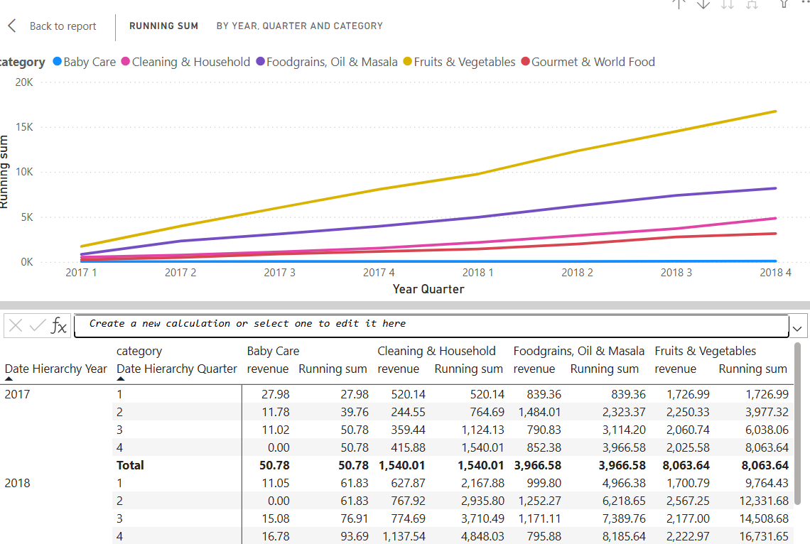

# 9.Configure Bookmark

Bookmarks capture a specific view of a report, including filters, slicers, the page selection, and the state of visuals. Report authors and report consumers can create them.

# 10.Create custom tooltip

Custom tooltip will appear when report consumers hover the cursor over visuals. By default, the report tooltip receives all filters that apply to the visual.

## 10.1 Default tooltip.

I will create a custom tooltip for my sales when I selected sales for example i want to have data concerning stock in this month.

I added just in the visualization tooltips the semantic .

## 10.2 Custom tooltip

You can also create more sophisticated tooltip.

You create a new page and add it the visual that you want after that you go to canvas settings and set as tooltip.

Before configuring settings in Caneva for tooltip :

It is not difficult you should just create your tooltip page on a new page and name it .

After that you should just go to the page where the visual that you want to add tooltip go to format and tooltips and choose report page and select the page

Result:

# 11. Edit and configure interaction between visuals.

By default, when report consumers interact with visuals, filters are propagated to other visuals on the report page. This way, visuals behave like slicers. For example, a report consumer can select a column of a column chart visual to filter other visuals on the page. To remove the cross filters, they can either select the column again or select a different visual.

As you can see below it is synchronized by default but we can stop it thanks to format / edit interaction, but you should select the slicer.

You can now select and remove from the second visual interaction.

As you can see below now the revenue, sales and stock stay static in the second multi row card.

# 12. Configure Navigation for a report.

# 13. Apply sorting to visuals

# 14. Group and layer visuals by using Selection pane .

# 15. Configure drill through navigation

 Allow report consumers to drill from visuals. By default, the drillthrough action propagates all filters that apply to the visual to the drillthrough page.

# 16 configure export settings

To see the data being used to create a visual, [you can display that data in Power BI](https://learn.microsoft.com/en-us/power-bi/consumer/end-user-show-data), or export it to Excel.

The export is limited in report with the permission, if you don’t have the permission , you can not export see security part (sensitivity label)

# 17. Design report for mobile device .

# 18. Enable personal visuals in report

# 19. Design power bi for accessibility

# 20. Configure automatic page refresh

When you monitor critical events, you want data to be refreshed as soon as the source data is updated. For example, in the manufacturing industry, you need to know when a machine is malfunctioning or is close to malfunctioning. If you're monitoring signals like social media sentiment, you want to know about sudden changes as soon as they happen.

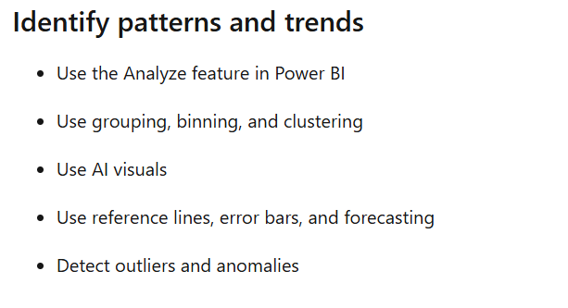

# 21) Use the Analyze feature in Power bi

The Analyze feature provides you with further analysis that's generated by Power BI for a selected data point in a visual. You might use this feature to see if Power BI found something new or to gain new insights into your data. This feature is useful for analyzing why your data distribution looks the way that it does.

It is available in few visuals like (bar chart , line chart ) .

It helps to understand the distribution, why some values are higher or lower .

A visual is created automatically in order to understand why we have a decrease at this moment and it creates a graph.

You can add to page with the button

If you find some anomalies you can also use this analyse to understand the root cause of this anomaly.

# 22) Use grouping,binning and clustering

It is possible to group the data with group on power bi visual , it will allow you to aggregate all data in a group and analyse these data as you want see image below .

## 22.1 Grouping

You have just to righ click on the visual and click on group .

You can create a list of group in order to analyze more easily your set of data .

For example create list with fresh food and other .

Data will be aggregated in function of the group(s) created.

22.2 Binning

You can also do that for the numerical value, we will use bin in this case .

For example, we will take the sales in function of the price , we can aggregate the price in range of price in order to analyse volume sales .

It is difficult to analyse but thanks to binning .

Right click on price and create new group.

After that you have just to configure the size or count of bin .

For example, i divide by range of 10 unit so i will have 850/10=85 groups .

As we can see above.

22.3 Clustering

Clustering allows you to identify a segment (cluster) of data that's similar to each other but dissimilar to the rest of the data. The process of clustering is different to that of grouping, which you learned about in the previous unit.

The Power BI clustering feature allows you to quickly find groups of similar data points in a subset of your data. It analyses your semantic model to identify similarities and dissimilarities in the attribute values, and then it separates the data that has similarities into a subset of the data. These subsets of data are referred to as *clusters*.

For example, you might want to look for patterns in your sales data, such as the behavior of customers overall. You can segment customers into clusters according to their similarities, such as age or location.

Start by adding the scatter chart visualization to your report and then add the required fields to the visual. In this example, you add the Order Qty field to the A-axis, the Sales field to the Y-axis, and the Unit Price field to the Values.

The following image shows considerable data in the scatter chart, so it's difficult to discern any natural groups.

You should use scatter plot with value,x-axis and y-axis then you have just to click on 3 points in the visual and find cluster.

After it will appear in your fields , you click on the cluster price (in our case) and edit cluster.

# 23) Use AI visuals

## Key influencers

The **Key influencers** visual helps report consumers understand the factors that drive a particular metric, like sales revenue. By using AI, Power BI analyzes the data, ranks the factors that matter, and then presents them as key influencers.

In the following example, the visual helps report consumers understand the important factors that contribute to won sales opportunities. According to the visual, when the discount rate increases by 2 percent, the likelihood of a won sales opportunity increases by a factor of 2.76.

## Decomposition tree

## QA:

# 24) Use reference line,error bars and forecasting

If you have time data in your data source, you can use the *forecasting* feature. Select a visual, then expand the **Forecast** section of the **Analytics** pane. You might specify many inputs to modify the forecast, such as the **Forecast length** or the **Confidence interval**. The following image shows a basic line visual with forecasting applied. Use your imagination (and play around with forecasting) to see how it might apply to your models.

In function of the visuals you can use forecasting or not .

## 24.1 Forecasting

## 24.2 error bars

## 24.3 reference line

# 25) Detect outliers and anomalies

An outlier is a type of anomaly in your data. It's something that you don't expect or that surprises you, based on historical averages or results. You should identify outliers to isolate data points that significantly differ from other data points and then take action to investigate the reasons for the differences. This analysis can make a significant effect on business decision making.

You can identify easily outlier thanks to the scatter chart on power bi to see the value which are outliers.

For example, as we can see, we have a point which is outlined in comparison with others.

The visual updates to show the data based on the selected fields, making it easy to spot outliers, which are the items separated from the main data points.

Now we can investigate the reason behind it.